Case 7-Colombia-Tairona-Gold-800-1600 CE-Synthesis

Tairona refers to indigenous groups of the Sierra Nevada de Santa Marta and of the adjacent Caribbean coast of Colombia from ca 300 AD/CE to 800 AD/CE – Proto-Tairona Period; 800 AD/CE – Pre-Conquest Period to the Spanish Conquest, ca 1600 AD/CE; Spanish Conquest Period ca 1600 AD/CE - ca 1700 (Reichel-Dolmatoff 1953: 17–27; Bischof 1971; 1982–83). The indigenous oral tradition of the Sierra Nevada of Santa Marta recognizes four groups originating in the massif: Kogi, Sánha, Kankuama and Ika. Each with its own territory and its language: all belong to the Chibcha linguistic family (Reichel, 1949: 24). In what follows we shall restrict our investigation to the Kogi, (spelled variously as Cogui or Kágaba) which means "jaguar" in Kogi of the Chibchan language family.

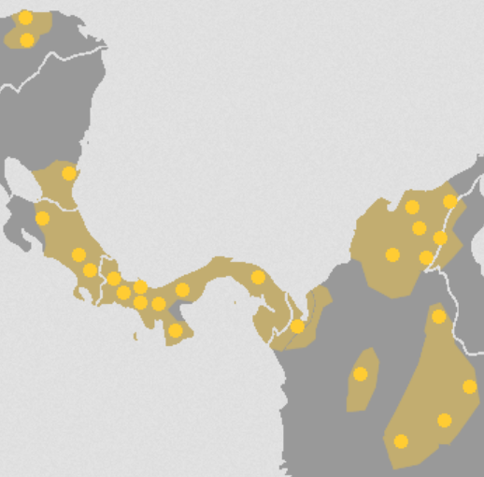

Fig. Map of the Chibchan language family in Costa Rica, Panama and Colombia. After https://upload.wikimedia.org/wikipedia/commons/1/1f/Chibcha_lang.png

**Origins of the Tairona Culture**

Proto-Tairona Period; 800 AD/CE – Pre-Conquest Period to the Spanish Conquest, ca 1600 AD/CE

In 1969 Henning Bischof described a collection of sherds from a pre-Tairona construction fill at Pueblito and linked them with the contents of an exceptional tomb excavated by J. Alden Mason at Nahuange (Bischof 1969a; 1969b). He dated this Nahuange (or Neguanje) phase to approximately A.D. 500–700 on the basis of ceramic cross-ties with Mina de Oro to the west and with the Red-on-Buff wares of the Ranchería to the east. He also recognized that many elements of the Nahuange assemblage were carried over into Classic Tairona. There is now general agreement that Nahuange defines an “early Tairona” or “proto Tairona” phase. Subsequent excavations by Jack Wynn (n.d.) at Buritaca, Langebaek (1987a) at Papare, and Augusto Oyuela Caycedo (1986; 1987a) at Cinto and Gaira have confirmed the stratigraphic position of the Nahuange phase—later than the incised and modeled Malamboid styles, earlier than Classic Tairona—and placed it between approximately A.D. 300 and 800– 1000. This is in line with the C-14 dates for the earliest “proto-Tairona” goldwork. In terms of distribution, a string of Nahuange sites is located along the coast, from Ciénega in the west to La Sierrecita, in the Guajira region well to the east of the Tairona

Pre-Conquest Period 800 AD/CE to the Spanish Conquest ca 1600 AD/CE

A period of Circum-Caribbean migrations included the Mesoamericans who originally inhabited Central America and at ca 1200 BCE they domesticated corn, and were followed by a second wave in 500 BCE. Chibchas (who were a Central American, ethno-linguistic group that encompassed the Tairona) travelled from Nicaragua and Honduras and reached Colombia shortly before the Arawaks arrived in Colombia from the south migrating from Brazil, Uruguay, and Paraguay. The Tairona settled along the northern spur of the Sierra Nevada de Santa Marta in La Guajira Department, forming a confederation of two groups, one in the Caribbean lowlands and the other in the highlands of contemporary Sierra Nevada de Santa Marta. The Tairona inhabited numerous hidden towns.



Fig. A peaceful Tairona Highland village as it would have appeared before the Spanish Conquest ca 1600 AD/CE

The hidden towns were hierarchically organized and connected by well-engineered stone roads in the jungle. Many of these towns are still hidden today.

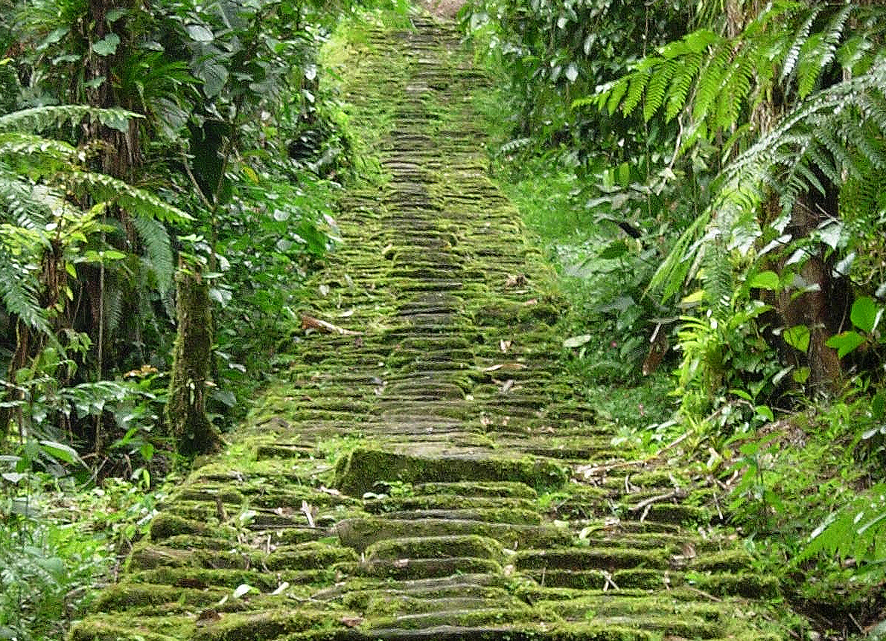

Fig. Tairona engineered road in the highlands of Sierra Nevada de Santa Marta in La Guajira Department.

The Tairona build engineered, complex circular stone works that were used for ritual performances involving a highly evolved priesthood and shamans that probably catered to the élite.

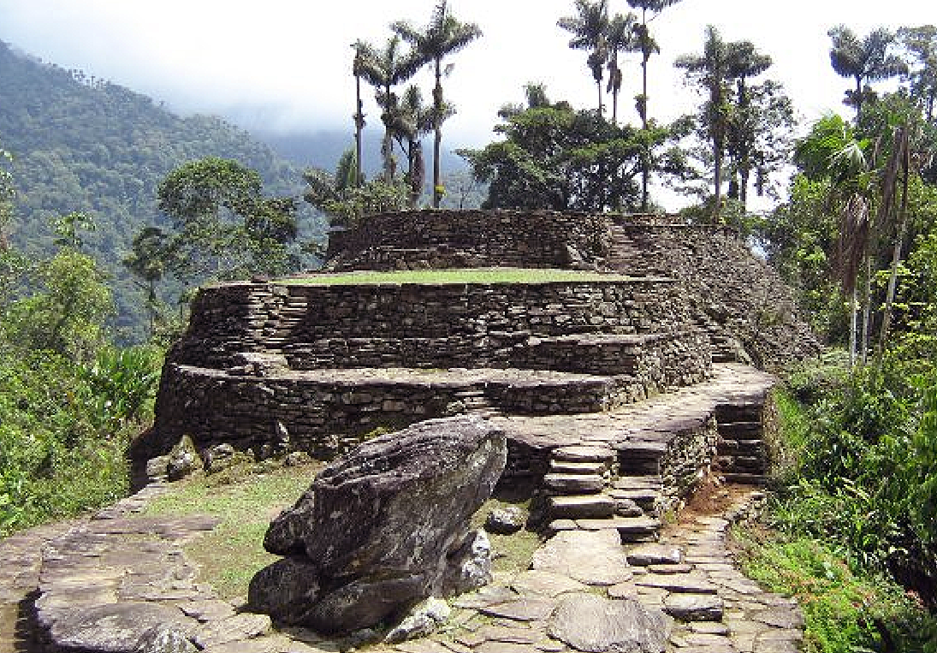 

Left: Fig. A Tairona pyramidal series of circular house platforms of undressed stone preceded by a massive baetyl or aniconic image of their primary deity seen in the foreground to act as a massive apotropaic idol to dispel alien forces. Right: Fig. A circular Tairona house with a baetyl at its entrance.

Lowland Tairona irrigated maize fields, fished and produced salt, all of which were traded for exquisite gold objects and textiles with their highland counterparts. Tairona gold objects were produced to enhance the prominence of the hierarchy and to communicate the spiritual and political ideals of the Tairona culture. They were not produced primarily as art objects.

When the Spanish invaded ca 1600 BCE, they aggressively and unconscionably dismantled the thriving, advanced culture of the Tairona. As Julian Haynes Steward (1902 – 1972) American anthropologist (best known for his role in developing "the concept and method" of cultural ecology, as well as a scientific theory of culture change) summarized the devastation of the Circum-Caribbean cultures including the Tairona:

“The Spanish Conquest dislodged the tribes from their native habitat, especially on the coasts and the more favored highland areas, and threw them back into sub-marginal lands where subsistence could not support large population clusters or special classes of artisans, priests, warriors, and nobles. At the same time, the Spanish government seized political controls from the native nobles, and Spanish military power put an end to warfare, thus destroying the class structure... The distinguishing socio-religious factors were thus destroyed, and the more elaborate craft products in weaving, metallurgy, ceramics, building arts, and the like lost meaning, for they had been designed largely for the native upper classes. There remained only a simple folk culture: simple farming people, an unstratified society, shamanism, and unelaborate textiles, ceramics, and other craft products made for home consumption. The surviving tribes retain a native culture which resembles that of the Tropical Forest peoples who have also simple technologies and a simple socio-religious pattern.” (Steward in Lyon 1974: 14).

The characteristic defense strategy against the Spanish and other “civilized ones” has been to remove to more and more distant territories. Theie reinforcement of hierarchical religious authority is to impose an institution that allegedly has a ceremonial language called “the Teyuan”, which only very few élite individuals handle and it is characterized, according to many Tairona, as being "very difficult and heavy".  
  
Consequently, to remain “hidden” the Tairona now inhabit the northern slopes in the valleys of the Don Diego, Palomino and Anch rivers, which are the most heavily forested and with the greatest precipitation. In addition smaller villages have been seen on the western slope, in the valley of the Tucurinca River, and southwest of the Sierra, in the region of the Guatapurí River. Since these Tairona have chosen to remain “hidden” anthropologists have been loath to penetrate their sanctity.

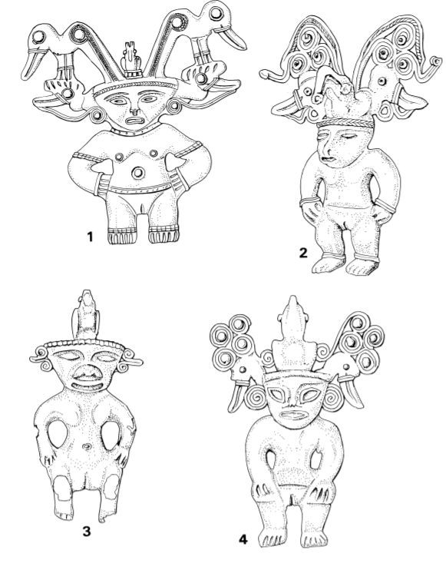

Early Tairona figure pendants

homeland (Langebaek 1987b; Ardila 1996: 55 and personal communication, 1999). Redpainted sherds that may possibly belong to this period have been reported from Las Animas, 360 meters above sea level on the northern slope of the Sierra (Herrera de Turbay 1985: 100, 105), but on present evidence the Nahuange phase is a littoral phenomenon, occupying precisely the area that the modern Kogi regard as the cradle of their culture (ReichelDolmatoff 1985, 1: 254). By the eighth or tenth century, transitional Nahuange-Tairona pottery had appeared at Buritaca 200, at 900 to 1,300 meters above sea level (Oyuela Cacedo 1986a), and the mature Tairona tradition was becoming established. Gold and stonework of the period also reflect the Tairona elements identified in Nahuange pottery. Mamorón, near Gaira, has stone roads, house-rings of undressed boulders, urn burials, and shaft-and-chamber tombs (Oyuela Caycedo 1987a). From El Chicharrón, on the upper Río Córdoba, came a Nahuange-style offering pot containing a stone mask (Reichel-Dolmatoff 1986: 241, fig. 173). Ana Mariá Falchetti (1987; 1993) has identified a corpus of gold items that are stylistically intermediate between the earliest Caribbean-Isthmian goldwork (the Initial and International Groups of Bray 1999) and mature Tairona metalwork (see also Fig. 2, nos. 1–4, and Gairaca d in the appendix).

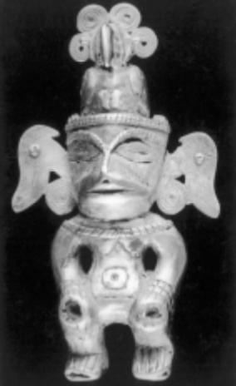 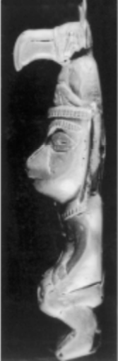 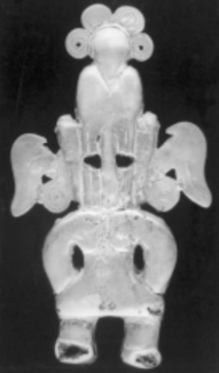

Tumbaga figure pendant from the Nahuange Site 1 tomb. H. 9 cm (photos by Stuart Laidlaw).

Early, pan-Caribbean, categories of goldwork include eagles, double-spiral pectorals, and animals with recurved tails; other items—disks, winged nose pieces, embossed crescentic plaques, and figurine pendants—are prototypes of Classic Tairona forms. The figurine pendants (Figs. 10 and 11) have complex headdresses incorporating spirals, lateral projections, and big-beaked birds. They are clearly ancestral to Classic Tairona forms, though they are less detailed, have prognathous non-Tairona faces, and are consistently female, in contrast to the male-dominated Tairona iconography. On the basis of headdress shapes, these figurines can be arranged in a typological series (not yet supported by contextual evidence), beginning with simpler, more pan-Caribbean types (Fig. 10. 3) and progressing, by way of more elaborate ribbons and whorls (Fig. 10. 1–2, 4), into mature Tairona categories. Radiocarbon dates have been obtained from the cores of two of these figurines. The figurine from the Nahuange tomb (Fig. 11) was dated A.D. 310 +/- 70 (OxA-1577), a century or two earlier than Bischof’s proposed date for the grave; the other pendant (Fig. 10. 1) is stylistically further down the road toward Classic Tairona and gave a date of A.D. 1035 +/- 90 (OxA-1528). Between them, these two C-14 dates approximately mark the beginning and end of the Nahuange period. An early beginning for proto-Tairona metalwork is confirmed by three more C-14 dates on core material from items in the Museo del Oro (Plazas 1998: 51–53). A bird pendant, said to be from Rio Palomino and similar to those in the Nahuange tomb (cf. Fig. 12), was dated A.D. 480 +/ - 40 (Beta 97375); a rather different form of bird pendant yielded A.D. 210 +/- 90 (Beta 108844); and a nose piece with lateral prolongations was dated A.D.130 +/- 40 (Beta 108840). All dates

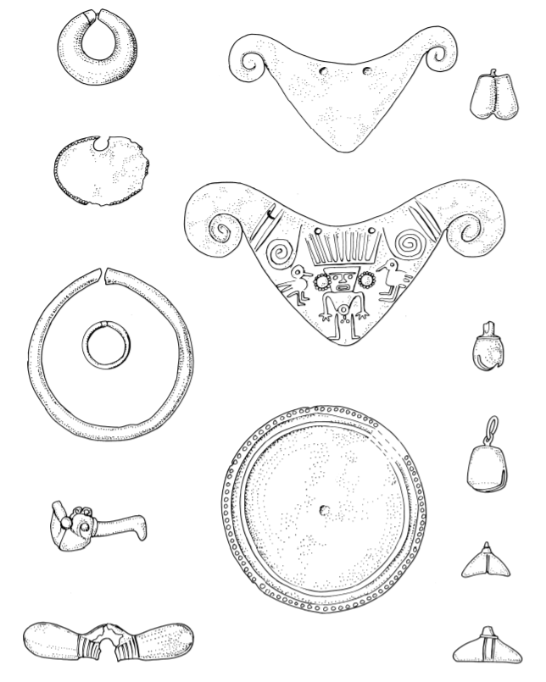

Metal items from the Nahuange Site 1 tomb (redrawn from Mason 1931–39)

The Nahuange tomb This grave, excavated by Mason (1931–39: 32–36) at Nahuange Site 1, is the type-site for the phase as a whole and is still the only locality where a range of artifacts in all media has been excavated by a professional archaeologist. The tomb consisted of a low circular mound, Fig. 12 Metal items from the Nahuange Site 1 tomb (redrawn from Mason 1931–39) 326 Warwick Bray 14 to 15 meters in diameter, with a retaining wall and, in the center, a rectangular grave lined with stone slabs and sealed by capstones. The soil of the mound contained bones and offerings. Teeth and fragments of bone were found in the fill of the tomb and in some of the pottery vessels, but it proved impossible to establish how many individuals were interred there. Mason’s descriptions indicate some kind of multiple burial, but it is not clear whether one corpse was more significant than the others. In total, Mason found more than 8,000 stone beads of various colors, winged pendants, artifacts of nephrite and other jadelike stones, gold jewelry, shell objects, resin pendants, and more than 30 pots. These included 19 or 20 cache vessels, some with lids (there is an ambiguity in Mason’s report). Of these, 3 vessels were empty, 3 contained only fragments of bone, 5 had only beads and stones, 1 contained three little pots, and the remaining 3 had gold and other artifacts. All categories of goldwork except the beads are illustrated in Figures 11 and 12, though some were represented by more than one example. Most of these gold objects (22 pieces of jewelry, 2 fragments of thin sheet, and a mass of beads) were found together in the largest vessel and may perhaps have belonged to a single elite individual. Other items were found in the loose soil of the grave. A similar pattern of cached items and loose artifacts was present in the mound. One lidded vessel from the mound held a gold ornament of thin metal and a gold ring. Several other pots with gold ornaments and beads were later excavated from the mound by a local cattleman, and one of these items is a typical early Tairona raised-tail animal (Mason 1931–39: pl. CXLVIII, 9). Because of the way Mason’s report is structured, it is not always possible to reunite vessels with their contents or to match his listings with the artifact descriptions and illustrations. The concentration of prestige items suggests that ranked, or chiefdom, societies had emerged in northern Colombia during the early centuries after Christ. In its form and construction, Nahuange is a Tairona tomb and belongs to the elite end of the range (compare, for example, Pueblito Site XXIX in the appendix). More significant, Nahuange also reflects Tairona patterns of behavior and the philosophical concepts that lie behind them: caches in pots (some of them obvious prototypes for the Tairona treasure jars but decorated with non-Tairona incised motifs or with red-painted Ranchería designs), the symbolism of beads, and the deposition of offerings in the soil around burials. As Bischof has demonstrated, the pottery from the tomb looks forward to Classic Tairona, but it also draws on earlier influences from all over Caribbean Colombia. The same is true of the gold and stone artifacts. The tubular rings and nose ornaments, disks, bells, and crescentic plaques are essentially Tairona, but the animal figure from the mound links this assemblage to the early goldwork from the Sinú region and the Caribbean lowlands in general (cf. Falchetti 1995: figs. 55, 59). The human figurine (Fig. 11) also has its roots in the same area, where the spiral ear ornaments and the heads of big-beaked birds occur on early Sinú eagle pendants and face bells (Falchetti 1995: figs. 35–36). In more developed forms, these bird motifs continue into Classic Tairona iconography (Fig. 9). Mason also excavated a number of artifacts made of nephrite and other jadelike minerals. These pieces comprised several winged, or bar, pendants (Fig. 13), a bead, an object in the form of a jaguar tooth, and six human figure pendants (Fig. 14). Like the metal figures of the

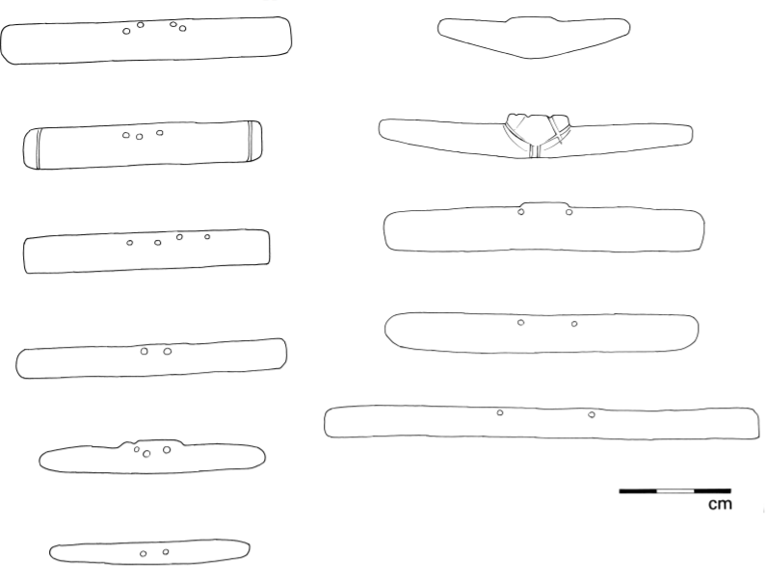

Stone pendants from the Nahuange Site 1 tomb (redrawn from Mason 1931–39)

Nahuange period, whenever the sex is clearly indicated, it is female. Holes at the shoulders indicate that the figurines were originally designed to hang upright, but several of them have extra holes on one edge, allowing them also to hang horizontally; some have been split vertically to convert them into bar pendants. All had been well used before burial, and only half of each split figure was deposited in the tomb. Unprovenienced finds of this type (Mason 1931–39: 191; Reichel-Dolmatoff 1986: 176; Sáenz Samper and Lleras Pérez 1999; photo 60) show that the figures from Nahuange are not unique. A single split figure pendant (though made of softer slate) was excavated from one of the largest Classic Tairona structures at Pueblito (Fig. 14. 5, and Mason 1931–39: 191). The Tairona and the Macro-Chibchan World In his earlier publications, Reichel-Dolmatoff (for example, 1965: 157–158) argued that the Kogi do not fit easily into any South American cultural pattern and that many of their cosmological and philosophical concepts indicate migration from Mesoamerica in preHispanic times. Because of this conviction, he did not investigate the parallels (such as the layered universe of the Kuna) between Kogi beliefs and those of their Chibcha-speaking neighbors. In later publications, Reichel-Dolmatoff modified his diffusionist views, while continuing to accept the Mesoamerican and Costa Rican connections (Reichel-Dolmatoff

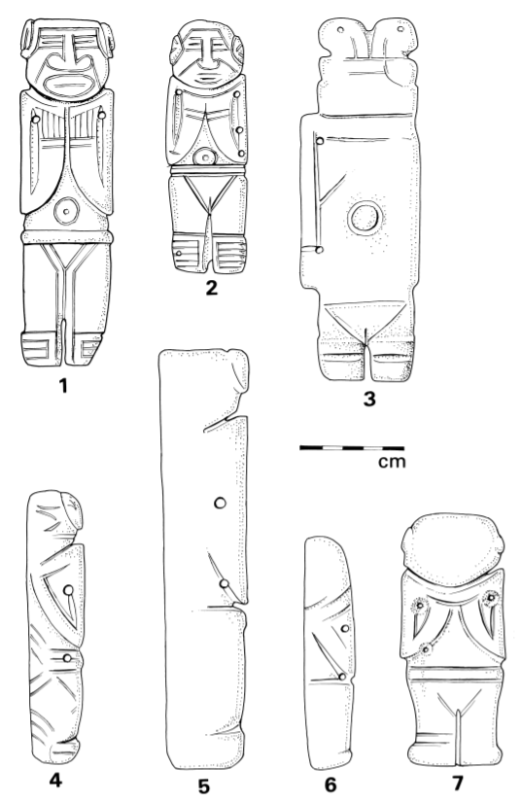

Stone figure pendants from the Nahuange Site 1 tomb (nos 1–4, 6–7) and from Pueblito Site 31 (no. 5) (nos. 1–4 redrawn from photos in the archive of the Field Museum, Chicago, 1954, negatives A94874–94850; nos 5–7 redrawn from Mason 1931–39)

1986: 198). His more recent position, that close contacts and mutual influences linked the regional cultures of Costa Rica, Panama, and Caribbean Colombia, fits much better with the archaeological evidence (Bray 1984: 322–337). It can now be demonstrated that Classic Tairona culture developed in situ and did so at a time when the region was open to foreign influences from many parts of the Isthmus and northern South America (Bray 1984; Langebaek 1989–90; 1992). Most of the peoples of the Isthmian-Colombian region spoke languages of the Chibchan family at the time of contact, and this has led some archaeologists (Bray 1999; Zamora and Hoopes, in this volume) to wonder whether the cultural similarities indicate not only intergroup contacts but also an underlying Chibchan “worldview” at the intellectual level. If so, many Tairona-Kogi beliefs and attitudes may have their equivalents elsewhere. There is still no conclusive evidence, but the origins of Tairona culture must be considered within the context of the Macro-Chibchan debate and with a focus on the centuries between A.D. 300 and 800. Looking outwards from Colombia and toward the Isthmus, we can see a pattern that is not easy to explain. The Caribbean lowlands of Colombia (Sinú and Urabá) and the Chocó on the Pacific side have obvious cultural ties with adjacent areas of Panama (Bray 1984; Cooke 1998; Falchetti 1993; Sáenz Samper and Lleras Pérez 1999). In contrast, the closest archaeological parallels for Nahuange and for the Tairona assemblage in general are not with the southern Isthmus, but with the cultures of Atlantic Costa Rica. Perhaps, as Ifigenia Quintanilla has suggested (personal communication, 1999), connections by sea as well as by land should be investigated. In the words of one Costa Rican specialist: After A.D. 500, drastic shifts began to occur in Costa Rican Precolumbian cultures. Circular houses became the norm and were indicative of a probable shift in cosmology or “world view.” New ceramic styles including resist painting proliferated; tomb forms and burial customs changed; cobble-paved roads within and between sites appeared; and metallurgy supplanted jade carving as the principal supplier of political and religious badges of power and authority. Gold replaced jade as the most symbolic material. All these traits appeared earlier in, and are typical of, northern South America, but the process by which these shifts to Costa Rica took place is not yet clear. (Snarskis 1998: 90) This view starkly contradicts Reichel-Dolmatoff’s ideas about the main direction of flow, and many aspects are indeed far from clear. While some specialists would be less dogmatic than Michael Snarskis about many of these “South American” traits, in one respect his argument is unassailable: The spread of metalworking from Colombia to the Isthmus (represented by the Initial and International Groups) is documented elsewhere (Bray 1992; 1999), and the distribution maps show a marked concentration of these early items in Atlantic Costa Rica. This area, too, is one of the points where the Mesoamerican and Chibchan worlds came into contact (Bray 1977: 390– 392). At Guácimo, for example, Maya stonework, Initial and International gold objects in the Urabá substyle of Colombia (Uribe 1988), and locally made jadeite versions of these (espe

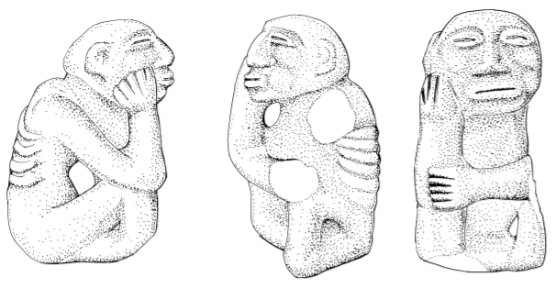

Stone sculpture from the Quebrada de Valencia, between the Guachaca and Buritaco Rivers, Sierra Nevada de Santa Marta. H. 24.5 (redrawn from Dussán de Reichel 1967)

cially animals with raised tails), occur in the same cemetery with pottery dated circa A.D. 400–600 (Stone and Balser 1965). In Costa Rican terms, this coincides with the few centuries during which gold and jade objects were used side by side (Guerrero 1998), as they were at Nahuange at more or less the same time. Apart from metallurgy, most of the traits shared by Costa Rica and the Tairona zone are either general (circular stone house-rings, paved roads, cist tombs and mounds, jade carving) or have a wide distribution throughout the Isthmus (winged pendants, small anthropomorphic and zoomorphic carvings in colored stones, eagle pendants, masked human figures and composite creatures of gold [Bray 1999: 44]). The case for a special relationship would be stronger if Costa Rican export pieces could be identified in Colombia, but there are very few items from the Tairona zone that may indicate direct links. An eagle pendant of gilded tumbaga from Minca is an undocumented find and could have come from anywhere in the Veraguas–Gran Chiriquí region of the Isthmus (Langebaek 1989–90, fig. IXb; Sáenz Samper and Lleras Pérez 1999: photo 67). The stone sculpture in Figure 15 is another casual find, from the north slope of the Sierra Nevada, and, as Dussán de Reichel (1967) points out, has close similarities with the sukia figures of central and southeastern Costa Rica (though the coca bulge in the left cheek suggests manufacture in Colombia rather than the Isthmus). There are, however, two very specific connections between the Tairona region and the Atlantic Watershed of Costa Rica, though the chronological control is so poor that we cannot say where these traits originated. The first of these similarities is the treatment accorded to jade figure pendants. Certain pendants from both areas have holes that allowed them to be hung vertically or horizontally (compare the Nahuange examples with, for example, the Costa Rican axe god from La Fortuna, another Atlantic cemetery with Maya connections [Stone and Balser 1965: fig. 4b]). Still more evocative is the custom of splitting jade figures into two vertical halves, converting the halves into horizontal bar pendants, and eventually depositing just one portion of the figure in the tomb. Split-figure pendants occur at Nahuange and Pueblito (Fig. 14) and in the jadeworking zones of Costa Rica, but they are unknown elsewhere. The use of jade may simply reflect availability of the raw material, but this unusual pattern of behavior suggests shared beliefs or rituals and goes beyond mere typology. Another artifact that could hardly have been invented twice is illustrated in Figure 16. These spoon pendants were made of pottery in Atlantic Costa Rica (nos. 1–2), where they are thought to belong to the Zoned Bichrome period (Stone 1977: 158). One example was found by a pothunter at La Fortuna, though its association with the Zoned Bichrome cemetery cannot be proved (Doris Stone, personal communication, 1981). In Colombia they were carved from stone (nos. 3–4), and their distribution appears to cluster around Dibulla, just beyond the eastern frontier of Classic Tairona territory (Mason 1931–39: 205–207). The Colombian items are casual finds, but none of these “spoons” has ever been excavated in a Classic Tairona context. It is possible, therefore, that they belong to the Nahuange period, Fig. 16 Spoon-shaped objects: nos. 1–2, clay, from Atlantic Costa Rica (redrawn from Stone 1977: fig. 212b); nos. 3–4, stone, from Colombia; no. 5, gold, from the Tairona region (after Plazas 1987). 332 Warwick Bray which would bring them into line with their Costa Rican counterparts. They may also be prototypes for later Tairona gold artifacts (Fig. 16.5). I have (Bray 1999) suggested that archaeological changes recognizable in several regions of Colombia around A.D. 600 might be linked with the arrival of Chibcha speakers from the Isthmus, among them the ancestors of the Tairona. Adolfo Costenla Umaña believes that the linguistic split between the Isthmian and Colombian branches of Chibchan occurred much earlier than this, in which case Chibcha-speaking groups were already well established in Caribbean Colombia, and the interactions described above took place between ethnic groups that at one time shared a common history (Costenla Umanã 1995; Sáenz Samper and Lleras Pérez 1999: 84–87). How much of the Tairona belief system goes back to that distant period is a matter for speculation and is a question that will not be answered by comparing artifact types. To complement the archaeological data, we need an extension to Colombia of the genetic and linguistic programs already carried out in the Isthmus (Barrantes et al. 1990), and more comparative work on the mythologies and cosmologies of the surviving Chibcha-speaking groups.

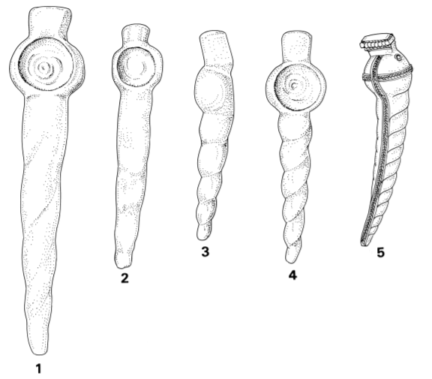

Spoon-shaped objects: nos. 1–2, clay, from Atlantic Costa Rica (redrawn from Stone 1977: fig. 212b); nos. 3–4, stone, from Colombia; no. 5, gold, from the Tairona region (after Plazas 1987)

**The Origins of the Kogi**

The Kogi are descendants of the [Tairona](https://en.wikipedia.org/wiki/Tairona) archaeological culture, an advanced civilization which built many stone structures and stone-paved pathways in the jungles. They made many gold objects which they would hang from trees and around their necks. Pedro de Aguado, writing in 1581, describes the appearance of the Indians in the sixteenth century, before the old customs had disappeared: “Their persons are much adorned with objects and jewels of gold. The men wear ear-ornaments, each of which weighs 15 and 20 pesos, and caricuries in their noses, hanging from the cartilage in the middle, and great chaguales, which are like round plates and half moons [cf. Figs. 3 and 7 ] on their chests. And around their necks they put many kinds of beads made of bones and shells and green stones, which are much appreciated among them, and beads and metalwork made of gold. The women wear much the same jewels as I have described for the men, including very large bracelets and hanging items of gold, and on their legs above the ankles and on their calves they wear big beads of chaquira [shell], gold and bone, as much as each one’s husband can afford, and they also wear these on the fleshy parts of their arms. Similarly, on their chests they put certain moldaduras [cast figures?] of gold, and with these they go covered,” (Reichel-Dolmatoff 1951: 83).

**The Kogi Cosmos, Mother and her Sons:**

The Kogi are one of four culture groups that were encompassed by the Tairona. What follows is estricted to the Kogi unless otherwise stated.

A detailed study of Kogi cosmology is provided in several papers by Reichel-Dolmatoff (1975; 1985; 1987; 1990). The central figure of Kogi religion is the Universal Mother, creator at the beginning of time of the cosmic egg that encompasses the universe. This egg-shaped universe has nine superimposed levels, and humankind occupies the middle one of these. The four upper levels (nyui-nulang, sun worlds) each have their own suns. The sun of the third level is Teiku, who lives there with his “family” of celestial beings, planets, and constellations.The cosmic egg is supported on two beams held up by four of the Mother’s sons, who are also the lords of the four directions or corners of the world and of the sun’s extreme positions (the solstices and equinoxes). The Mother is not directly represented in Tairona goldwork or in present-day Kogi ritual costumes. After the Universal Mother, the principal divine personifications are her sons—Seokukui, Seizankwa, Kuncavitabueya, Aldauhuiku, and Mulkuexe—and their innumerable descendants. Through their roles in various acts of creation, all these figures are also spirit-owners (Mothers, Fathers, Dueños) of different aspects of nature, rulers over the rituals, and “the appointed guardians of certain aspects of human behaviour—cultural and biological” (Reichel-Dolmatoff 1977: 269). Many of these creator figures and dueños are the protagonists in today’s Kogi rituals and dances, and I believe there are references to these personages and concepts in prehistoric Tairona goldwork. Ritual Artifacts of Gold The modern Kogi use ancient gold artifacts in their rituals (though they keep these items well hidden), and they talk of the days when gold was plentiful (Reichel-Dolmatoff 1981; Ereira 1990). Gold also figures in their myths, in particular the narrative of Taiku (Teiku), recorded by Konrad Theodor Preuss in 1915 as told by a mama at Palomino. Other myths make it clear that Taiku is an aspect of the sun, especially in his image as the solsticial sun (Reichel-Dolmatoff 1987: 86), and he is also the Father of gold and of metallurgy in general. In early times the younger brother Taiku used to make golden utensils for the mamas. After he had lived in the Sierra with the elder brothers, the younger brother Taiku went to the Rio Lagarto [on the coast] and during his stay there he began to make things of gold for the elder brothers. He made little tubes of gold, pectorals and ear ornaments. On their arms and legs they wore all sorts of ornaments, made by the younger brother, Taiku. Everything had to be kept in the ceremonial houses. For the dance in the ceremonial house he made gold diadems, golden caps, golden adornos with feathers, and seats to support the feather headdresses. In those days the younger brother Taiku made golden belts for both men and women, golden shirts, caps, carrying bags, lime flasks and the dippers for eating lime. He also made gold trumpets, rattles, flutes, seats and ceremonial houses of gold. The younger brother made all these things so that the original families of the Kágaba could wear these golden jewels for the dance in the ceremonial house, so that the apprentices could wear them, to consecrate the harvest, call the rain and invoke drought. . . . . He made other things of gold: catfish, snakes, crabs, birds, etc. He made all sorts of birds and four-legged animals in gold. Also a golden figure like a human being. This is what our fathers told us. (Preuss 1993, 2: 32–33) The Taiku narrative describes, with some exaggeration but essential truth, the golden regalia and utensils once used by the mamas, and emphasizes the divine origin of these items. Kogi traditions also maintain that in ancient times the Sun was dressed in gold (ReichelDolmatoff 1981: 25) and that, before the Spanish stole them all, even the divining bowls were made of gold (Ereira 1990: 194). As the Taiku myth indicates, gold ornaments were an essential component of the dance costumes worn by the mamas. The dances, which still punctuate the Kogi year, are to promote human welfare—to ensure harvests, control the elements, banish diseases, and so on— and to preserve harmony and balance within the cosmos and between mankind, the supernatural ancestors, and the forces of nature (Preuss 1993; Reichel-Dolmatoff 1985: 130– 143). As the Kogi explain it, “Bailamos para no morir” (we dance in order not to die) (ReichelDolmatoff 1985: 135). The ceremonies have three principal components: confession, dance, and offerings. For the dances the priests wear wooden masks representing various supernaturals—the sons of the Mother, Death, the dueños, etc.—and special costumes that closely resemble those of the contact period Tairona. Preuss and Reichel-Dolmatoff discuss these costumes in detail. A much-published photograph (Preuss 1993, 1: fig. 33; Looper 1996: fig. 13) illustrates a priest in the costume of Heisei (Death, the Master of diseases and of human sexuality), wearing a semicircular feather headdress, a kilt of dangling fibers, and a wooden mask. Joseph de Brettes (1903) also recorded these elements (Fig. 4), which are still in use today (Zuidema 1992: fig. 5). All three components—panache, kilt, and mask—appear on anthropomorphic clay ocarinas from pre-Hispanic Tairona sites (Fig. 5), and the mask of Heisei, with its protruding lower jaw and crossed fangs (sometimes sheathed with gold) can also be recognized on these whistles (Mayr 1986: 57). The sacramental qualities of gold jewelry are illustrated by a nocturnal ritual witnessed by Reichel-Dolmatoff in a temple or ceremonial house:

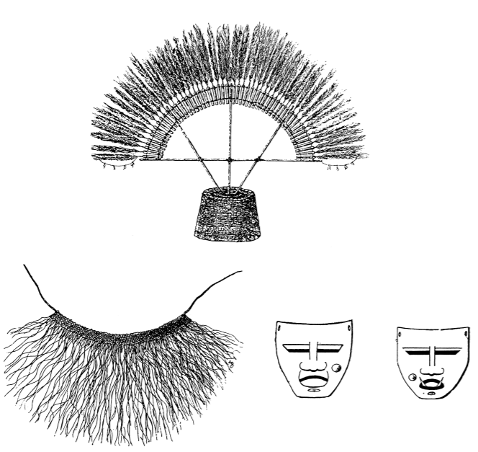

Items of Kogi ritual costume (after De Brettes 1903)

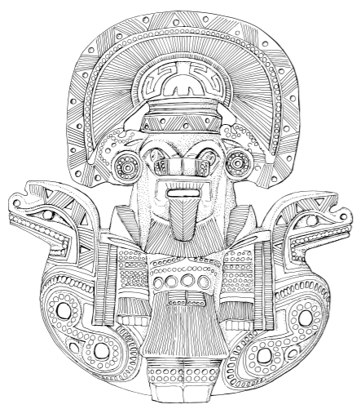

Fig. 5 Tairona clay ocarina depicting a masked figure in ritual costume. H. 11 cm

a mama personified the Sun, and his wife the Moon. These personages wore carved wooden masks, his representing a jaguar and hers a black puma. The ritual finished when the participants in the ceremony had a resplendent internal vision. “The gold began to shine” and the brilliance of the masks, bracelets and ear-ornaments worn by the mama and his wife induced visions. After carrying out a part of the ceremony in silence, and waiting until dawn, the personages Sun and Moon took off their masks and jewels, and the mama lit a new fire in the four hearths of the building. (Dussán de Reichel: 2000: 93) Mamas and all men of status (adults over the age of 40 or 50) take part in the dances. Their costumes incorporate pre-Hispanic gold ornaments, especially armbands and ligatures in which Tairona gold bells and spacer plates are combined with stone beads (Mason 1931– 39, pls. CLIX–CLXIII). Little gold bells are sewn onto the shoulders of dance outfits (Mason 1931–39: 261), and sashes are decorated with gold or copper ornaments in the form of turtles, felines, and pelicans and other birds (Reichel-Dolmatoff 1985, 2: 142). Masks and gold regalia also play a role in the training of apprentice priests, as the Teiku story indicates. The training is arduous and is carried out under the tutelage of experienced mamas, in seclusion and darkness, over two nine-year cycles. At the age of four or five, the child apprentice is given his first gold ornaments: bracelets, rings, and necklaces of gold and stone beads. A year or two later he receives his wooden dance mask and feather crown, and his gold ornaments are augmented with necklaces and pectorals. Dressed in this regalia, for hours on end, night after night, the children are taught the dance steps, the cosmological recitals, and the elements of the creation story that together constitute the Law of the Mother (Reichel-Dolmatoff 1977: 279; 1985, 2: 120; 1990). It is this knowledge that will give the boys status and power in the community when they become fully-fledged mamas.

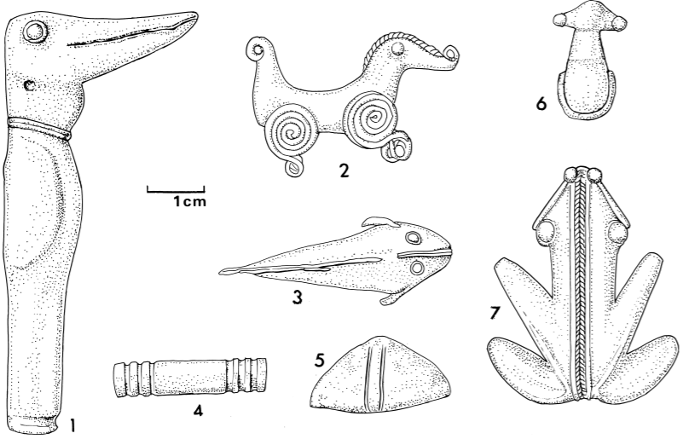

Metal items from Herbert Huntingdon Smith’s excavations at Gairaca, Carnegie Museum of Natural History (nos. 2 and 3 redrawn from Benson 1997: figs. 2 and 89)

In ca 1000 AD/CE the Kogi were forced to flee into the mountains from the invading Caribs. This was a tactical decision that proved strategically beneficial 500 years later. In 1498 the Spanish Conquistadors invaded. These professional soldiers were ordered to enslaving the Kogi. They began by using lethally trained mastiffs against children, hanging Kogi priests, abducting and raping Kogi women, and brainwashing Kogi children to accept Spanish education and Catholicism. Then the Pope ordered Spanish missionaries to enslave Kogi men to build Catholic churches in the middle of Kogi villages in order to destroy any vestiges of Kogi religion.

Then the Spanish founded the port of Santa Marta in 1524, and they sent military expeditions of enslavement to establish control over all of the Kogi people in order to steal their gold objects. The Spanish had no interest in preserving these most complex and intricate gold objects ever made in the Americas. These objects were cast of tumbaga (an alloy of gold and copper) by the lost-wax process with a surface enriched in gold by the depletion method, also known as mise-en-couleur. The gold objects depicted sacred animals, Kogi caciques (rulers and prominent persons), humans often with zoomorphic attributes suggesting the shamanic ability to transform oneself into the spirit of ancestors, sacred animals and birds.   
 Spaniards had no interest in either the Kogi culture or the expertise these artisans had demonstrated in making unsurpassed gold objects. Rather, the Conquistadores were willing to exploit any culture for gold for it was gold that Charles V of the Holy Roman Empire needed to fund his war of extermination on the Muslim Moors. For example, a minor shipment of gold was discovered in 1991 in an unidentified 1528 wreck of a Spanish galleon off Grand Bahama Island. It had 200 ingots of tumbaga that represented hundreds of plundered gold possessions that had been stripped of the people and melted down only to be hastily shipped to the Spanish Crown in the midst of a winter storm because on Jan 22 England and France had declared war on Emperor Charles V (see Armstrong 1993).

**Masked Human Figures** The rarest and finest cast objects, the most “elite” items of Tairona goldwork, are human figure pendants, either free standing (Figs. 8, 9) or attached to bird-shaped back plates (Mason 1931–39: pl. CL, left). Similar figures, with both human and bat faces, are represented on gold bells, presumably from dance costumes, and are seated on top of bird heads on certain eagle pendants (for example Reichel-Dolmatoff 1988: figs. 26, 47; Labbé 1998: fig. 95). As a group these humanoid figures are colloquially called caciques. In the professional literature they have been labeled bat men (Legast 1987: 85–99) or shamans (Reichel-Dolmatoff 1988: 144). The first of these two labels is simply a descriptive shorthand, and the second identification seems unlikely, since Reichel-Dolmatoff elsewhere insists that Kogi mamas are not shamans, but rather an institutional priesthood (Reichel-Dolmatoff 1990: 3). On the basis of their headdresses, three variants of the figure can be identified. The most common and most basic form wears a crescentic head ornamant (Fig. 8.1); the more elaborate versions have either a divided headdress (Fig. 8.2) or a complicated device incorporating birds and bird heads (Fig. 9). It is open to debate whether these variants represent different but closely related personages or three manifestations of the same one. What unites them is a set of regalia not found on other icons or depicted on burial urns and ceramic vessels. These identifying items are a braided headband, a visor (usually with two or three mushroom-shaped protuberances), double bars through the nose (as opposed to the more usual rings, crescents, and “butterflies”), a labret, ear rods and/or danglers, a braided band across the shoulders, and a braided belt. Many of these figures also hold horizontal bars with double spirals, or occasionally serpent heads, at both ends. In some instances the “bar” is clearly a belt, and the double spiral elements are grasped separately in the hands. One of these figurines wears a bird pendant (Fig. 8.1), but this is the only example I know thus far. The find spot is reported as Jirosaca, and the archive of the Museo del Oro indicates that it may possibly have been associated with two more gold items—a bird pendant and a human figure wearing a divided headdress from which hang bats (Sáenz Samper 2003). Anything made of organic materials has disappeared from the record, but the occurrence of full-sized nose bars and visors made of gold suggests that these are actual Tairona costumes worn by real people (see, for example, the grave lot from Minca in the appendix). Reichel-Dolmatoff (1987: 95) has suggested that the visors depicted on the pendants represent the tortoiseshell visor worn by Seizankwa, the Lord of the East, though Nicolás de la Rosa notes that rich Indians wore diadems of tortoiseshell, and poor ones of plaited palm “made in a semicircle and placed about the head to protect the eyes from the heat of the sun and to retain the hair” (Nicholas 1901: 612). Whenever the sex is depicted, the figure pendant is male and wears a penis cover and a waist cord. Many of these personages—perhaps all of them—are masked. Anne Legast (1987; 1989) gives compelling reasons for identifying the nonhuman faces as bats and discusses the multiple role of bats in Kogi mythology, their links with menstruation and fertility and with Sun (Muluku), Death (Heisei), and various other supernatural personages. Bats also hang from the side pieces of the divided headdresses. Other masks represent big-beaked birds (Legast 1987: fig. 107) or a combination of bat and bird wearing the same regalia as the other figures (Reichel-Dolmatoff 1988: pl. 238: Mason 1931–39, pl. CL, left). The bat-bird mask is also represented on Tairona clay ocarinas (Reichel-Dolmatoff 1986: fig. 164). The masked individuals in present-day Kogi ceremonies represent the sons of the Universal Mother (natural and cosmic forces, the Mothers, Fathers, and Dueños) and are her messengers or agents on Earth (Reichel-Dolmatoff 1985, 2: 255). Despite the enormous variety of masks and ritual costumes represented on the clay ocarinas (cf. the range of modern costumes described by Preuss and Reichel-Dolmatoff ), Tairona goldsmiths made only a limited selection from them, and there is no way of knowing which individual, or individuals, is the icon of the figure pendants. Rather than trying to determine who the figure is, it may be more advantageous to look at the ideas behind the representations. Kogi masked dancers do not simply “become,” or transform into the personages whose costumes they wear. The relationship is more complex and subtle (Reichel-Dolmatoff 1985, 2: 94–95). By wearing the mask, the dancer becomes “in agreement with” the deity, or dueño, becoming his brother, or his equal, and, as a member of the deity’s “family,” is in a position to mediate between the community and the ancestral or supernatural world. In this context, one might guess, even if it cannot be proved, that gold pendants representing masked figures served to establish connections between humanity and the cosmic or supernatural forces, had a protective role, and at the same time reinforced the status of those members of society who had knowledge of the traditions and were allowed to wear the masks.

**A Kogi View of Tairona Gold** Given the degree of continuity of ritual practices from pre-Hispanic times to the present, one way of resolving these ambiguities might be to ask the Kogi themselves who these images represent and what they mean. This has never been systematically attempted, though in conversations with Legast a Kogi mama identified one of these figures as a god (name unspecified), dancing and wearing a mask (Legast 1987: 96). Alan Ereira (1990) showed Mama Valencia, a respected Kogi priest, a series of original and replica gold objects and recorded his comments. The breastplates and wrist bands were explained as dance regalia: These are haga. They wore them to dance with, they wore them around their necks and wrists, when they danced to call the rains and to bless the trees and rivers. When you want to speak to the ancestors you wear these haga. (Ereira 1990: 170) The personage in Figure 8.1, was said to be a vampire bat, a costume worn by the mamas; other figures represent the sons of the Universal Mother. One of the most elaborate of all Tairona images (Fig. 9.2) was identified as Namsiko, one of the world-creating sons of the Mother. The whorls of his headdress symbolize eight of the nine “worlds” or levels of the Kogi cosmos, and the figure itself symbolizes the missing (middle) world—the one in which we live. Mama Valencia further explained, Namsiko is a chief. The birds, the snakes, the jaguars [the ubiquitous animals of Tairona iconography], they’re all like the vassals of Namsiko. He was the chief of all the animals. First came the earth, then came Namsiko, and then he was in charge of everything. When they first started to make gold, Namsiko was there making the pots to house the gold. (Ereira 1990: 166) The birds on the headdress were described as condors. In one version of Kogi cosmology, Namsiko and Sintana hold up the eastern ends of the two beams that support the cosmos (Reichel-Dolmatoff 1985, 1: 225) and like any other Dueño or Father, Namsiko today has his own dance mask (ibid., 2: 132–133). 322 Warwick Bray Namsiko’s pots are part of a chain of associations that links the gold figurines with the golden animals, with the Tairona practice of caching ritual objects, and with the Kogi belief that, from the time of creation, everything has its Mother, Father, or spirit-owner: All our gold pieces and stone beads should live in pots, but now they are all scattered. . . . Serankua said that all things should have their houses. We see them as pots but Serankua made them as houses; the Great Mother created all things in their pots. . . . The Mother of the birds was a little bird in gold kept in a jar, the Mother of the jaguar was a little jaguar. All of them lived in their pots, all of them have been taken. (Ereira 1990: 164–165) The same idea of owners and houses appears also in Ika beliefs: The fathers put gold in the mountain peaks. These peaks are like houses, And as a house is owned by someone, And has its occupants, So are each of the peaks. (Tayler 1997: 36) As John Rowe (1946: 316) has remarked in another context, mythology is static only when people no longer believe in it. Today’s Kogi and Ika mamas (like the anthropologists who study them) interpret ancient Tairona artifacts in the light of their own 20th-century experiences, and their Truths may be just as subjective, but it is interesting that Kogi comments on the goldwork pick up on certain aspects of the problem that barely figure in the archaeological literature.

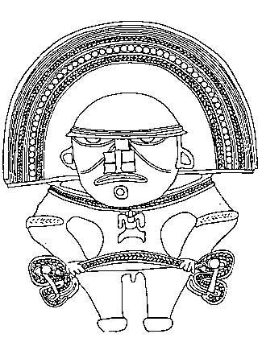 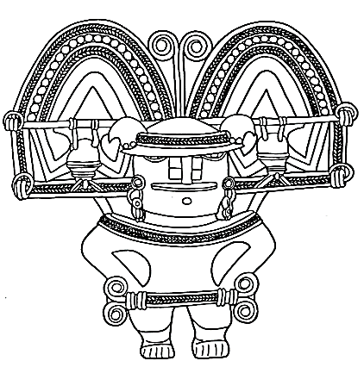 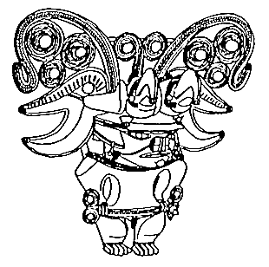 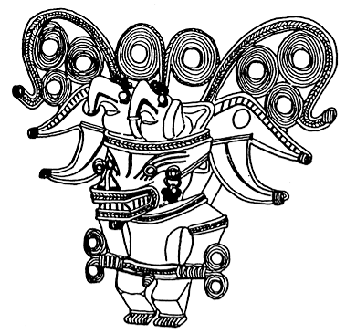

|  |  |
| --- | --- |
|  | **References**  Armstrong, Douglas R.1993. *Tumbaga silver for Emperor Charles V of the Holy Roman Empire: the study of a large trove of early 16th century Spanish silver bars recovered from a shipwreck off Grand Bahama Island.* Palm Bay, FL: The Author.  ARDILA CALDERÓN, GERARDO I. 1996 Los tiempos de las conchas: Investigaciones arqueológicas en la costa de la península de la Guajira. Universidad Nacional, Bogotá.  Barrantes, Ramiro, P. E. Smouse, H.W. Mohrenweiser, H. Gershowitz, J. Azofeifa, T. Arias, and J. V. NEEL 1990 Microevolution in Lower Central America: Genetic Characterization of the ChibchaSpeaking Groups of Costa Rica and Panama, and a Taxonomy Based on Genetics, Linguistics and Geography. American Journal of Human Genetics 46: 63–84.  BENSON, ELIZABETH P. 1997 Birds and Beasts of Ancient Latin America. University of Florida Press, Gainesville.  BISCHOF, HENNING 1969a Contribuciones a la cronología de la Cultura Tairona (Sierra Nevada de Santa Marta, Colombia). In Verhandlungen des 38 Internationalen Amerikanistenkongresses (Stuttgart– München 1968), vol 1: 259–269. 1969b La Cultura Tairona en el Área Intermedio. In Verhandlungen des 38 Internationalen Amerikanistenkongresses (Stuttgart–München 1968), vol. 1: 271–280. 1971 Die Spanisch-Indianische Auseinandersetzung in der nördlichen Sierra Nevada de Santa Marta (1501–1600). Bonner Amerikanistische Studien 1, Bonn. 1982–83 Indígenas y españoles en la Sierra Nevada de Santa Marta, siglo XVI. Revista Colombiana de Antropología 24: 75–124.  BRAY, WARWICK 1977 Maya Metalwork and its External Connections. In Social Process in Maya Prehistory (N. Hammond, ed.): 365–403. Academic Press, London. 1978 The Gold of El Dorado. Times Books, London. 1984 Across the Darien Gap: A Colombian View of Isthmian Archaeology. In The Archaeology of Lower Central America (Frederick W. Lange and Doris Z. Stone, eds.): 305–338. School of American Research and University of New Mexico, Albuquerque. 1992 Sitio Conte Metalwork in Its Pan-American Context. In River of Gold: Precolumbian Treasures from Sitio Conte (Pamela Hearne and Robert J. Sharer eds.): 33–46. University Museum, University of Pennsylvania, Philadelphia. 1999 Metallurgy and Anthropology: Two Studies from Prehispanic America. Boletín del Museo del Oro 42 (1997): 37–55.  CADAVID CAMARGO, GILBERTO, and ANA MARÍA GROOT DE MAHECHA 1987 Buritaca 200: Arqueología y conservación de una población precolombina (Sierra Nevada de Santa Marta, Colombia). Boletín del Museo del Oro 19: 57–81. 339 Gold, Stone, and Ideology  CADAVID, GILBERTO, and LUISA FERNANDA HERRERA DE TURBAY 1985 Manifestaciones culturales en el área tairona. Informes Antropológicos 1: 5–55. Instituto Colombiano de Antropología.  CARDOSO, PATRICIA 1987 Uso y significado de las cuentas tairona. Boletín del Museo del Oro 19: 117–123. n.d. Aproximación arqueológica al conocimiento de un asentamiento tairona. Graduate thesis, Universidad de los Andes, Bogotá, 1986. CASTELLANOS, JUAN DE 1955 Elegías de varones ilustres de Indias. Biblioteca de la Presidencia de Colombia. Editorial ABC, Bogotá.  COOKE, RICHARD 1998 Cupica (Chocó): A Reassessment of Gerardo Reichel-Dolmatoff’s Fieldwork in a Poorly Studied Region of the American Tropics. In Recent Advances in the Archaeology of the Northern Andes: In Memory of Gerardo Reichel-Dolmatoff (Augusto Oyuela-Caycedo and J. Scott Raymond, eds.): 91–106. Institute of Archaeology, University of California, Los Angeles.  COSTENLA UMAÑA, ADOLFO 1995 Sobre el estudio diacrónico de las lenguas chibchenses y su contribución al conocimiento del pasado de sus hablantes. Boletín del Museo del Oro 38–39: 13–55. DE BRETTES, JOSEPH 1903 Les Indiens Arhouaques-Kaggabas. Bulletins et Mémoires de la Société d’Anthropologie de Paris, 4, ser. 5: 318–357. DE LA ROSA, NICOLÁS 1975 Floresta de la Santa Iglesia catedral de la ciudad y provincia de Santa Marta. Biblioteca del Banco Popular, Bogotá.  DUQUE GÓMEZ, LUIS 1958 Notas históricas sobre la orfebrería indígena de Colombia. In Homenaje al Profesor Paul Rivet: 271–335. Academia Colombiana de Historia, Bogotá.  DUSSÁN DE REICHEL, ALICIA 1967 Una escultura lítica de tipología costarricense de la Sierra Nevada de Santa Marta. Razón y Fábula 2: 39–42. 2000 Continuité culturelle Tairona-Kogui. In Les esprits, l’or et le chamane: 87–95. Exh. cat. Réunion des Musées Nationaux, Paris.  EREIRA, ALAN 1990 The Heart of the World. Jonathan Cape, London. Published in the U.S.A. as The Elder Brothers, Knopf, New York, 1992.  FALCHETTI, ANA MARÍA 1987 Desarrollo de la orfebrería Tairona en la provincia metalúrgica del norte colombiano. Boletín del Museo del Oro 19: 3–23. 1993 La tierra del oro y del cobre: Parentesco y intercambio entre comunidades orfebres del norte de Colombia y áreas relacionadas. Boletín del Museo del Oro 34–35: 3–75. 1995 El oro del Gran Zenú: Metalurgia prehispánica en las llanuras del Caribe colombiano. Museo del Oro, Banco de la República, Bogotá.  FITZSIMMONS, ELLEN M. n.d. Animals, Territories and Totems among the Prehistoric Tairona (Colombia). Manuscript in the possession of the author, 1998.  FRIEDE, JUAN 1951 Breves informaciones sobre la metalurgia de los Indios de Santa Marta según documentos encontrados en el Archivo General de Indias, Sevilla. Journal de la Société des Américanistes de Paris, n.s. 40: 198–202.  GROOT DE MAHECHA, ANA MARÍA 1985 Arqueología y conservación de la localidad precolombina de Buritaca 200 en la Sierra Nevada de Santa Marta (1976–1977). Informes Arqueológicas 1: 55–102. Instituto Colombiano de Antropología.  GUERRERO, JUAN VICENTE 1998 The Archaeological Context of Jade in Costa Rica. In Jade in Ancient Costa Rica ( Julie Jones, ed.): 23–37. Metropolitan Museum of Art, New York.  HERRERA DE TURBAY, LUISA FERNANDA 1985 Agricultura aborígen y cambios de vegetación en la Sierra Nevada de Santa Marta. Banco de la República, Fundación de Investigaciones Arqueológicas Nacionales, Bogotá.  LABBÉ, ARMAND J. 1998 Shamans, Gods, and Mythic Beasts: Colombian Gold and Ceramics in Antiquity. American Federation of Arts and University of Washington Press, New York.  LANGEBAEK RUEDA, CARL HENRIK 1987a La cronología de la región tairona vista desde Papare, Municipio de Ciénega. Boletín de Arqueología 2 (1): 83–101. 1987b Relaciones de los desarrollos del área tairona y el intercambio. Boletín de Arqueología 2 (2): 32–41. 1989–90 Aguilas y caricuries: Venezuela y su coparticipación en el área orfebre de Colombia y el Istmo en el siglo XVI. Revista Colombiana de Antropología 27: 199–235. 1990 Documento sobre los tribus de la Sierra Nevada de Santa Marta, Archivo General de Indias, Sevilla. Relación de Nueva Salamanca de la Ramada de 1578. Revista de Antropología y Arqueología 6 (2): 107–124. 1992 Noticias de caciques muy mayores: Orígen y desarrollo de sociededes complejas en el nororiente de Colombia y norte de Venezuela. Universidad de los Andes, Bogotá. 341 Gold, Stone, and Ideology LEGAST, ANNE 1987 El animal en el mundo mítico tairona. Banco de la República, Fundación de Investigaciones Arqueológicas Nacionales, Bogotá. 1989 The Bat in Tairona Art: An Under-recognized Species. In Animals into Art (H. Morphy, ed.): 270–286. Unwin Hyman, London.  LLERAS PÉREZ, ROBERTO 1985 Excavaciones de salvamento en la Sierra Nevada de Santa Marta. Informes Antropológicos 1: 103–132. Instituto Colombiano de Antropología.  LOOPER, MATTHEW G. 1996 The Iconography and Social Context of Tairona Gold Pectorals. Journal of Latin America Lore 19: 101–128.  MASON, J. ALDEN 1931–39 Archaeology of Santa Marta, Colombia: The Tairona Culture, 3 vols. Anthropological series, 20 (1–3). Field Museum of Natural History, Chicago.  MAYR MALDONALDO, JUAN 1986 Geschichtliche Überlieferung und Ruinenstätten im Gebeit der Tairona-KulturSierra Nevada de Santa Marta. In Tairona-Goldschmiede der Sierra Nevada de Santa Marta, Kolumbien (Corinna Raddatz, ed.): 56–61. Hamburgischen Museum für Völkerkunde, Hamburg.  NICHOLAS, FRANCIS C. 1901 The Aborigines of the Province of Santa Marta, Colombia. American Anthropologist, n.s. 3: 606–649.  OLIVER, JOSÉ R. 2000 Gold Symbolism among Caribbean Chiefdoms: Of Feathers, Çibas, and Guanín Power among Taíno Elites. In Precolumbian Gold: Technology, Style and Iconography (Colin McEwan, ed.): 196–219. British Museum, London.  OYUELA CAYCEDO, AUGUSTO 1986a Excavación de un basurero en Ciudad Perdida, Sierra Nevada de Santa Marta. Boletín de Arqueología 1(1): 28–34. 1986b Contribución a la periodización cultural en el Litoral del Parque Tairona. Boletín de Arqueología 1 (2): 24–28. 1987a “Gaira”: Una introducción a la ecología y arqueología del litoral de la Sierra Nevada de Santa Marta. Boletín del Museo del Oro 19: 34–55. 1987b Implicaciones de las secuencias locales y regionales en los aspectos culturales de los Tairona. In Chiefdoms in the Americas (Robert A. Drennan and Carlos A. Uribe, eds.): 213–228. University Press of America, Lanham, Md. 1998 Ideology, Temples and Priests: Change and Continuity in House Societies in the Sierra Nevada de Santa Marta. In Recent Advances in the Archaeology of the Northern Andes: In Memory of Gerardo Reichel-Dolmatoff (Augusto Oyuela-Caycedo and J. Scott Raymond, eds.): 39–53. Institute of Archaeology, University of California, Los Angeles.  PLAZAS, CLEMENCIA 1987 Forma y función en el oro tairona. Boletín del Museo del Oro 19: 25–33. 1998 Cronología de la metalurgia colombiana. Boletín del Museo del Oro 44–45: 3–72.  PREUSS, KONRAD THEODOR 1993 Visita a los indígenas Kagaba de la Sierra Nevada de Santa Marta: Observaciones, Recopilación de Textos y Estudios Lingüísticos. Instituto Colombiano de Antropología, Bogotá.  REICHEL-DOLMATOFF, GERARDO 1951 Datos histórico-culturales sobre las tribus de la Antigua Gobernación de Santa Marta. Instituto Etnológico del Magdalena, Santa Marta. 1953 Contactos y cambios culturales en la Sierra Nevada de Santa Marta. Revista Colombiana de Antropología 1 (1): 15–122. 1954a Investigaciones arqueológicas en la Sierra Nevada de Santa Marta, pts. 1–2. Revista Colombiana de Antropología 2 (2): 145–206. 1954b Investigaciones arqueológicas en la Sierra Nevada de Santa Marta, pt. 3. Revista Colombiana de Antropología 3: 139–170. 1958 Notas sobre la metalurgia prehistórica en el litoral Caribe de Colombia. In Homenaje al Profesor Paul Rivet: 69–94. Academia Colombiana de Historia, Bogotá. 1965 Colombia. Thames and Hudson, London. 1967 Notas sobre el simbolismo religioso de los Indios de la Sierra Nevada de Santa Marta. Razón y Fábula 1: 55–72. 1975 Templos Kogi: Introducción al simbolismo y a la astronomía del espacio sagrado. Revista Colombiana de Antropología 19: 199–245. 1977 Training for the Priesthood among the Kogi of Colombia. In Enculturation in Latin America: An Anthology ( Johannes Wilbert, ed.): 265–288. University of California at Los Angeles, Latin American Center, Los Angeles. 1981 Things of Beauty Replete with Meaning: Metals and Crystals in Colombian Indian Cosmology. In Sweat of the Sun, Tears of the Moon: Gold and Emerald Treasures of Colombia (Peter T. Furst et al., eds.): 17–33. Natural History Museum Alliance of Los Angeles County, Los Angeles. 1985 Los Kogi: Una tribu de la Sierra Nevada de Santa Marta, Colombia (2nd edition). Procultura, Nueva Biblioteca Colombiana de Cultura, Bogotá. 1986 Arqueología de Colombia: Un Texto introductorio. Presidencia de la República, Litografía Arco, Bogotá. 1987 The Great Mother and the Kogi Universe: A Concise Overview. Journal of Latin American Lore 13 (1): 73–113. 1988 Orfebrería y chamanismo: Un Estudio iconográfico del Museo del Oro. Colina, Medellín. 1990 The Sacred Mountain of Colombia’s Kogi Indians. Iconography of Religions, sec. 9, South America, fasc. 2. Institute of Religious Iconography, Leiden, and State University, Groningen. 343 Gold, Stone, and Ideology  REICHEL-DOLMATOFF, GERARDO, and ALICIA REICHEL-DOLMATOFF 1955 Investigaciones en la Sierra Nevada de Santa Marta, pt. 4. Revista Colombiana de Antropología 4: 189–245. ROWE, JOHN HOWLAND 1946 Inca culture at the time of the Spanish Conquest. In Handbook of South American Indians, vol. 5 ( Julian H. Steward, ed.): 183–330. Smithsonian Institution, Bureau of American Ethnology Bulletin 143, Washington, D.C.  SÁENZ SAMPER, JUANITA 2003 El vuelo de las águilas doradas: Aves con alas desplegadas en la orfebrería Tairona. Boletín del Museo del Oro 48 (enero-junio 2001).  SÁENZ SAMPER, JUANITA, and ROBERTO LLERAS PÉREZ 1999 Las relaciones pre-hispánicas entre los territorios de Costa Rica y Colombia. In Oro y jade: Emblemas de poder en Costa Rica (Roberto Lleras and Juanita Sáenz, eds.): 67–89. Museo Nacional de Costa Rica.  SAUNDERS, NICHOLAS J. 1998 Stealers of Light, Traders in Brilliance: Amerindian Metaphysics in the Mirror of Conquest. RES 33: 225–252.  SERJE, MARGARITA 1987 Arquitectura y Urbanismo en la Cultura Tairona. Boletín del Museo del Oro 19: 87–96. SIMÓN, FRAY PEDRO 1882–92 Noticias historiales de las conquistas de Tierra Firme en las Indias Occidentales. Medardo Rivas, Bogotá.  SNARSKIS, MICHAEL J. 1998 The Imagery and Symbolism of Precolumbian Jade in Costa Rica. In Jade in Ancient Costa Rica (Julie Jones, ed.): 59–91. Metropolitan Museum of Art, New York. STONE, DORIS 1977 Pre-Columbian Man in Costa Rica. Peabody Museum Press, Cambridge.  STONE, DORIS Z., and CARLOS BALSER 1965 Incised Slate Disks from the Atlantic Watershed of Costa Rica. American Antiquity 30 (3): 310–329.  TAYLER, DONALD 1997 The Coming of the Sun: A Prologue to Ika Sacred Narrative. Pitt Rivers Museum, Oxford. URIBE, MARÍA ALICIA 1988 Introducción a la orfebrería de San Pedro de Urabá, una región del noroccidente colombiano. Boletín del Museo del Oro 20: 35–53.  URIBE TOBÓN, CARLOS A. n.d. We, the Elder Brothers: Continuity and Change among the Kággaba of the Sierra Nevada de Santa Marta, Colombia. Ph.D. diss., University of Pittsburgh, 1990.  VÁZQUEZ DE ESPINOSA, ANTONIO 1942 Compendium and Description of the West Indies. Smithsonian Miscellaneous Collections, 102, Smithsonian Institution, Washington, D.C.  WYNN, JACK THOMAS n.d. Buritaca Ceramic Chronology: A Seriation from the Tairona Area, Colombia. Ph.D. diss., University of Missouri, 1975.  ZUIDEMA, TOM 1992 The Tairona of Ancient Colombia. In The Ancient Americas: Art from Sacred Landscapes (Richard F. Townsend, ed.): 245–257. The Art Institute of Chicago, Chicago.  **Individual Gold Figurines**  This gold figurine depicts a broad-shouldered male figure standing in a confrontational hands-on-hips stance. His head is that of a crocodilian or bat. He is wearing an animal mask with a square toothy snout and diamond-shaped nose leaf. Covering the head is an enormous headdress that is as tall as the figure itself. It has two big-beaked birds on the front of its cap and elaborate sidepieces with detailed spiral and braided elements.  Appendix: Documented Finds of Tairona Metalwork Pueblito a. Site VI (Mason 1931–39: 70) Buried inside a large house-ring were a black jar, a broken jar containing a gold “ornament,” a copper “whistle,” and many cornelian beads. Nearby, in loose soil, was another gold bracelet, more cornelian beads and a piece of thick bone. The nature of the entire deposit is unclear. b. Site XXIX (Mason 1931–39: 90–93) A large, stone-lined grave with a capstone, located on a terrace. Contents: a jar with 15 winged plaques of stone; a jar containing many stone beads, 3 gold bracelets, and 1 copper bracelet; a jar with many stone beads, pottery ocarinas, and 3 “fine stone ornaments”; a vessel with bits of copper wire, perhaps bracelets; a vessel with shells, fish vertebrae, 2 small limestone images; a pot with stone beads; a vessel with red and green stone beads. Elsewhere Mason mentions a bird pendant of fine gold from this grave, though this does not appear in his excavation description (p. 262, pl. CXLVII, 6). c. Site XXXII (Mason 1931–39: 103) A small stone-lined grave with an empty olla. “Scattered through the soil” were stone beads, stone axe heads, and “several gold ornaments.” One of these is a broken frog (p. 260 and pl. CXLVII, 2); another is a penannular ring (p. 252). From Mason’s description, and from the objects found in the soil (but not in the grave itself ), the round structure on the terrace may have been ceremonial rather than domestic. Miscellaneous finds in the soil included a pair of metal ear ornaments (pl. CXLIII, 3, 5) and what may be an anchor ornament (pl. CXLVI, 7). d. No Number (Reichel-Dolmatoff 1958: 73) From a stone ring already rummaged by treasure hunters was excavated a penannular tubular bracelet of rolled sheet metal, beside which were 2 little embossed disks of fine gold, 3 tubular beads of sheet metal, and a gold cap from a labret (Fig. 1.16). Associated with these were many sherds, and also stone items, including a monolithic axe. Jirosaca (Reichel-Dolmatoff 1958: 72) From a sealed offering vessel (context unknown) came the following items of “gilded copper”: a plaque with an embossed face, 18.5 cm high (Fig. 3.1); a large, plain hammered (?) armband 6.9 cm long (Fig. 3.2); a nose piece, 11.2 cms wide (Fig. 3.3); a large convex disk with a border of embossed dots, 14.5 cm in diameter (Fig. 3.4); 2 smaller discs with zigzag decoration, 9.4 cm in diameter (Fig. 3.5). Most of these items had holes for suspension or attachment. This deposit may have been a cache rather than a burial offering. 334 Warwick Bray Gairaca Items a–f derive from the Herbert Huntingdon Smith expedition of 1896–98. His finds are now in the Carnegie Museum of Natural History, Pittsburgh. Some of his specimens were illustrated by J. Alden Mason (1931–39). Ellen FitzSimmons (n.d.) has reconstituted several of Smith’s grave lots, and her study is supplemented here by reference to Smith’s field notes, the museum’s accession list, and museum photographs. I am grateful to Ellen FitzSimmons Steinberg and James B. Richardson III for providing this material. There are some inconsistencies between the documentary sources, but in general the fit is good. Smith notes that his graves were found in or close to house sites. In this appendix, Smith’s finds are listed by individual burial, that is, the content of a single urn. There were often several urns in a grave, and most of the ambiguities concern the positions of accessory vessels. At least three metal items were found loose in the earth of the graves, or came from rifled tombs. These are not included here. The remaining graves (items g–j) were excavated by Mason. a. A small, covered burial urn Contents: remains of a child under two years old, a fine brownware cup, and a tumbaga pendant or tinkler in the form of a seated frog (Fig. 2.6; acc. no. 2005/145). There is some ambiguity about whether a covered blackware bowl was inside or outside the urn. b. A large, sealed burial urn in the same grave as the above Smith believed the broken bones belonged to a single skeleton, accompanied by a tumbaga pendant in the form of a frog (Fig. 2.7; acc. no. 2005/158), a tumbaga bell, of “cowry shell” shape and with a greenstone pebble clapper (Fig. 2.5; acc. no. 2005/158a), 2 stone axe heads, and possibly a stone club. Three blackware bowls were either inside or outside the urn, and a jar cover was somewhere in the grave. In addition, Smith found a single small tumbaga batrachian somewhere in this general locality at a depth of 75 cm (Mason 1931–39: pl. CLIII, 7). c. A sealed urn, among several other jars Contained remains of a child ten years of age or younger, a tumbaga spread-wing bird pendant with a big beak (acc. no. 2005/122), a miniature stone axe, 2 birdlike shell ornaments, shell tinklers (on the cover of the jar), red stone beads, 2 carnelian pebbles, a cylinder of red stone, and an oxidized stone (?). Close to the urn were a sherd with a bird’s head and sherds from a fine, black, handled vessel. d. Large, covered urn in a grave containing five urns in all Contents: 3 adult males, 3 stone axes, 3 stone “clubs,” 4 unperforated red stone cylinders, shells, a stone (?), a shallow plate, “lime with a hole in it” (probably from the neck of a lime flask), 4 cylindrical tumbaga beads of rolled sheet (Fig. 2.4; acc. no. 2005/153d–g), a broken tumbaga spread-wing bird pendant (Mason 1931–39 pl. CLIII,1; acc. no. 2005/153a), an unusual tumbaga bird pendant (Fig. 2.1; acc. no. 2005/153), a tumbaga “anteater” pendant (Fig.2.2; acc. no. 2005/153c), and a fish pendant (Fig. 2.3; acc. no. 2005/153b). None of the metal items is typical of Classic Tairona. The fish is a Sinú, or possibly Isthmian, piece (Falchetti 335 Gold, Stone, and Ideology 1995: 127). The quadruped, too, was probably made in the Sinú area (cf. Falchetti 1995: 127– 129), though an identical animal, with no precise provenience, came to the Museo del Oro in a mixed Tairona lot (Legast 1987: fig. 15; Juanita Sáenz, personal communication, 1999). Whatever the place of manufacture, this entire group seems typologically early and may well belong to the Nahuange Period rather than to Classic Tairona. e. Large burial pot with cover Smith’s notes describe a covered urn (acc. no. 2005/301) containing bones, a stone axe (acc. no. 2005/160), and a “gold bell in the shape of a cowry shell” (acc. no. 2005/161). In the museum’s accession list, item 301 is a bead from Las Cruces. The other artifacts are missing and undescribed. f. Urn Contained at least 2 adult males, a stone club, a stone axe, 1 unperforated red stone cylinder, 19 carnelian pebbles, a tumbaga anchor ornament (Mason 1931–39: pl. CLIII, 2; acc. no. 2005/ 279), and a tumbaga feline bell (Mason 1931–39: pl. CLIII, 5; acc. no. 2005/279a). g. Urn burial (Mason 1931–39: 28) A child with 5 pots, 5 black pottery whistles, cornelian beads, bones of a small animal, and a broken frog of copper or low grade tumbaga. h. Urn burial (Mason 1931–39: 271) “In an urn at Gairaca were found many shell objects encrusted with, and held together by, copper.” i. Urn burial (Mason 1931–39: 263) A thin cast gold item, (?) part of an eagle pendant (Mason 1931–39: pl. CXLVI, 4). It is not clear what else was in the urn. j. Group of 7 burial urns (Mason 1931–39: 30) Around the base of the central urn were several stone axe heads and beads. Beneath it were human bones and a copper animal figure. Bonda (Angell Collection) (Mason 1931–39: 253) A stone-lined grave the contents of which included a pottery ocarina and a black pot with penannular metal ear ornaments. Chocuenca (Angell Collection, Cranbrook Institue of Science/Angell Archive, and Mason 1931–39: 256–258; information courtesy of Carole DeFord) A small stone-lined tomb with “bones.” Contents (not necessarily a complete listing): more than 20 broken stone axes, shell ornaments in the shape of nose rings, rock crystal beads, 1 cornelian toucan head, 1 quartz polishing stone. Of gold or tumbaga were half of a simple 336 Warwick Bray butterfly nose piece (similar to Fig. 1.5), 1 complete nose ornament (Mason 1931–39: pl. CLVI, 1), a broken gold disc (Mason 1931–39: pl. CLIV, 4) and possibly “a piece of gold” (the archive is ambiguous). Nahuange a. Site 2 (Mason 1931–39: 36, 253–254) Miscellaneous burials in “free soil,” rather than in urns or burial deposits. The finds included shell crocodile heads, tinklers and pendants, cornelian beads, 2 tumbaga plaques, and “a few other gold objects.” Somewhere on the site Mason excavated a pair of tumbaga penannular ear ornaments. b. Site 3 (Mason 1931–39: 37, 254–256) Many poorly described interments and one urn burial. Loose finds were distributed through the soil; other items were contained in pots. One fragmentary vessel contained small gold beads, small tubular carnelian beads, and large tubular beads of shell. “Other small vessels contained carnelian beads and [unspecified] ornaments of gold-copper alloy.” Somewhere on the site (exactly where is not mentioned) Mason excavated a pair of metal bracelets or cuffs (pl. CLV, 3) a “pectoral acoronazado” (pl. CXLV, 1) and 2 “butterfly” nose pieces (pl. CXLVI, 1–2). Buritaca 200 (Ciudad Perdida) a. Terrace 49, Tomb 2 (Groot de Mahecha 1985) Shaft tomb (in a house-ring) with a side chamber sealed by a grinding stone. Contents: 2 anchor ornaments (cf. Fig. 1.7), 2 penannular ear ornaments (cf. Fig. 1.11), 1 round cornelian bead, and 1 small carnelian owl effigy. Charcoal provided a C-14 date of A.D. 1385 +/- 45 (GrN-9247). b. Terrace 25 (Groot de Mahecha 1985) A damaged shaft tomb with a side chamber containing 4 tubular carnelian beads, 2 tumbaga anchor ornaments (cf. Fig. 1.10), 1 tumbaga nose piece (cf. Fig. 1.6), and 80 little square plaques of tumbaga, each with two holes for sewing to a textile backing, c. (Lleras Pérez 1985: 121–127) A shaft tomb within a house-ring. Contents: 39 tubular beads of green and red stone, 1 fragmented bead of sheet gold. San Jose de Minca (Museo del Oro archive; Sáenz Samper n.d.) The archive refers to 68 gold pieces from 8 (undifferentiated) tombs and to one nose piece (MO acc. no. 8648) found in place on a skull in a burial in a rock cleft. Minca (Museo del Oro archive; Sáenz Samper 2003) Report of a number of urns, each containing one or two metal frogs. 337 Gold, Stone, and Ideology Minca (Museo del Oro archive; Sáenz Samper 2003) From a single deep tomb with no pottery came 15 gold items (MO acc. nos. 8975–8991): an “eagle” pendant, various hollow semicircular ear pieces, a double-bar nose ornament, a chisel, 2 circular nose pieces, and a set of small plaques for sewing onto textiles (cf. Plazas 1987: fig. 16a). San Pedro de la Sierra (Museo del Oro archive; Sáenz Samper 2003) A shaft-and-chamber tomb containing a bird pectoral with three big-beaked heads (MO acc. no. 8974). There was no pottery. San Pedro (Museo del Oro archive; Sáenz Samper 2003) a. From a tomb of unknown form came 9 reportedly associated items: an eagle pendant, 2 penannular hollow ear ornaments, 2 penannular ear ornaments with wirework decoration, a cylindrical nariguera, 2 triangular necklace pieces with prolongations, and a collection of broken fragments. b. Report of an eagle pendant alone in a tomb. From the same place, bird pendants with “batmen” figures seated on top are said to occur singly in tombs. Finca La Esmeralda, Bonda (Museo del Oro archive, Sáenz Samper 2003) A report of “buttons,” and fragments of labrets and of narigueras in little offering pots. |
|  |  |